UNIVERSITY ADMISSION
DATABASE SYSTEM
Project Report
Database Design

Course: | Database Systems
Name: | NANZIRI SHAMIRAH
Reg Number: | 2025/BCS/142/PS
Date: | May 5, 2026
Database: | MySQL 8.0 (admission_db)

1. Introduction
This report documents the design, development, and implementation of a University-Level Admission Database System. The system provides a comprehensive platform to manage the complete student admission lifecycle that is from applying level up to when one is confirmed for enrollment

The project was implemented using MySQL 8.0 and it contains six relations.

1.1 Project Objectives
- Design a normalized relational database to support a university admission process.
- Implement account creation and secure authentication for applicants and administrators.
- Enable applicants to upload academic documents and select programs of study.
- Provide administrators with the ability to review, approve, or reject applications with mandatory remarks.
- Demonstrate the practical application of SQL, database normalization, and web integration.

2. Database Design
The admission_db database was designed following the principles of relational database normalization to minimize data redundancy and ensure data integrity. The database consists of six tables that collectively represent all entities involved in the university admission workflow.

2.1 Database Overview — MySQL Environment
The database was created and managed within MySQL 8.0. Figure 1 below shows the MySQL environment confirming the presence of the admission_db database alongside other system databases, and the six tables within it.

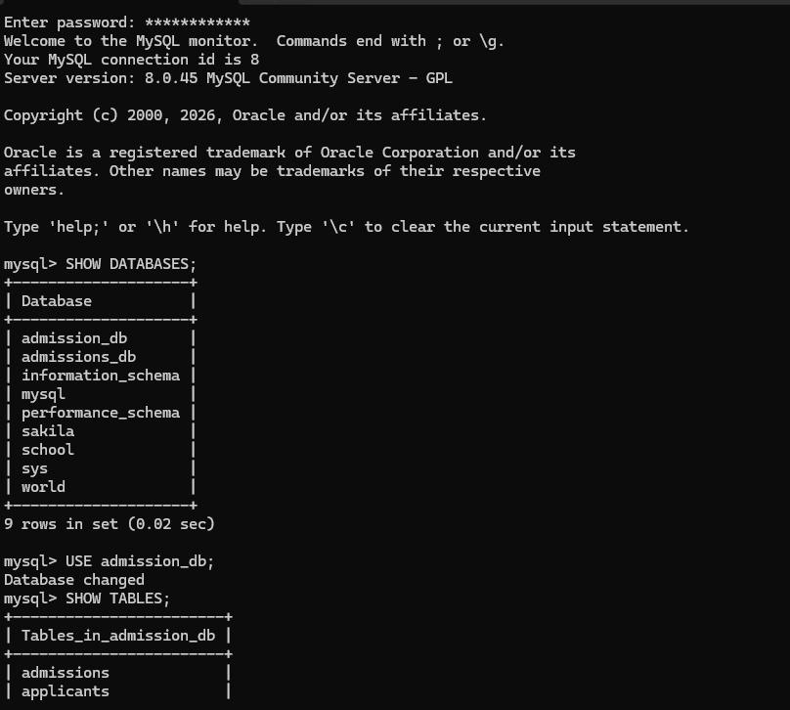

2.2 Entity-Relationship Overview
The six tables of admission_db are described below. Each table was designed to represent a distinct real-world entity in the admission process, with appropriate primary keys, foreign keys, and data types.

2.2.1 Applicants Table
Stores personal information about each applicant. The applicant_id is the primary key, and a password_hash column was added to support secure authentication.
applicant_id INT AUTO_INCREMENT PRIMARY KEY
first_name VARCHAR(100) NOT NULL
last_name VARCHAR(100) NOT NULL
date_of_birth DATE
gender ENUM('male','female','other')
email VARCHAR(150) UNIQUE NOT NULL
password_hash VARCHAR(255) NOT NULL
phone VARCHAR(20)
address TEXT
nationality VARCHAR(100)
created_at TIMESTAMP DEFAULT CURRENT_TIMESTAMP

2.2.2 Programs Table
Holds the academic programs available for application. Each program belongs to a faculty and department, and has a minimum grade requirement and a defined number of available slots.
program_id INT AUTO_INCREMENT PRIMARY KEY
program_name VARCHAR(150) NOT NULL
faculty VARCHAR(150)
department VARCHAR(150)
duration_years INT
degree_level VARCHAR(50)
available_slots INT
minimum_grade DECIMAL(5,2)

2.2.3 Applications Table
Links applicants to programs. Each application tracks its academic year, submission date, and review status. The status ENUM was extended to include 'Approved' and 'Rejected', and an admin_remarks column was added to store feedback for rejected applications.
application_id INT AUTO_INCREMENT PRIMARY KEY
applicant_id INT NOT NULL REFERENCES Applicants(applicant_id)
program_id INT NOT NULL REFERENCES Programs(program_id)
academic_year VARCHAR(20)
application_date DATE
status ENUM('Pending','Admitted','Approved','Rejected') DEFAULT 'Pending'
admin_remarks TEXT NULL -- Added for approval/rejection workflow

2.2.4 Documents Table
Stores metadata for files uploaded by applicants (e.g., National IDs, certificates). An application_id foreign key was added to associate documents with specific applications, enabling per-application document retrieval.
document_id INT AUTO_INCREMENT PRIMARY KEY
applicant_id INT REFERENCES Applicants(applicant_id)
application_id INT REFERENCES Applications(application_id) -- Added
document_type VARCHAR(100)
file_name VARCHAR(255)
submitted_at TIMESTAMP DEFAULT CURRENT_TIMESTAMP

2.2.5 Qualifications Table
Records previous academic qualifications for each applicant, including school name, certificate type (e.g., IGCSE), grade average, and year of completion.
qualification_id INT AUTO_INCREMENT PRIMARY KEY
applicant_id INT REFERENCES Applicants(applicant_id)
school_name VARCHAR(200)
certificate_type VARCHAR(100)
grade_average DECIMAL(5,2)
year_completed YEAR

2.2.6 Admissions Table
Captures the final admission record for successfully admitted applicants, including a generated student ID, intake period, and enrollment remarks.
admission_id INT AUTO_INCREMENT PRIMARY KEY
application_id INT REFERENCES Applications(application_id)
admission_date DATE
student_id VARCHAR(50)
intake VARCHAR(50)
remarks TEXT

3. Database Population & Verification
To verify the database design and functionality, all six tables were populated with representative sample data. The following screenshots confirm successful data entry and relational integrity across the tables.

3.1 Admissions & Applicants Records
Figure 2 shows the admissions table containing two approved records (for Computer Science and Business & Public Management programs) and the applicants table with three registered student accounts: Cedric Ahabwe, Gillian Kanyesigye, and Chris Nyangoma — all Ugandan nationals created on May 5, 2026.

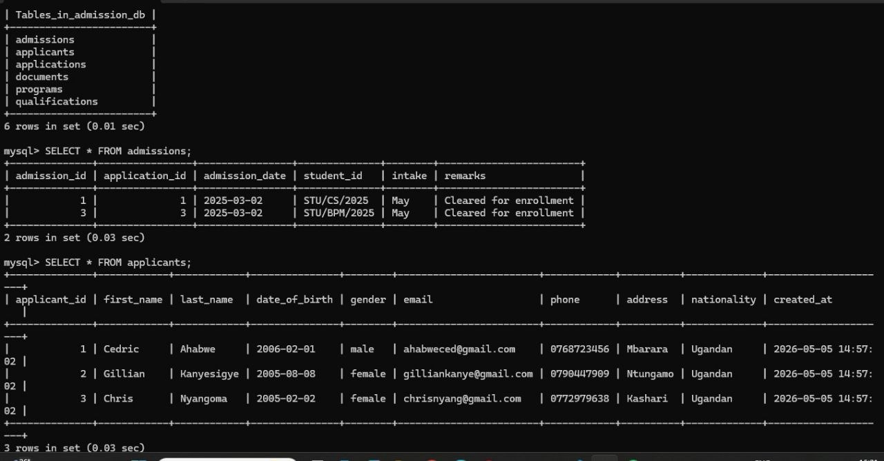

3.2 Applications, Documents & Qualifications
Figure 3 displays the applications table with three applications (statuses: Admitted, Pending, Admitted), the documents table showing uploaded files (National ID and certificates), and the qualifications table with IGCSE records from three different high schools with grade averages ranging from 70.00 to 82.00.
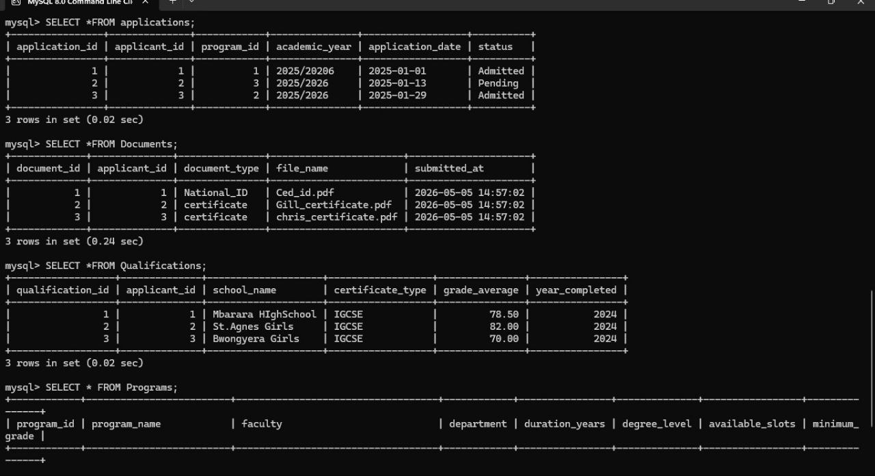

3.3 Programs Table
Figure 4 shows the Programs table containing three available undergraduate programs: Computer Science (Faculty of Science and Technology, 60 slots, min grade 65), Business Administration (Faculty of Business, 70 slots, min grade 55), and Medicine and Surgery (Faculty of Health Science, 30 slots, min grade 60).

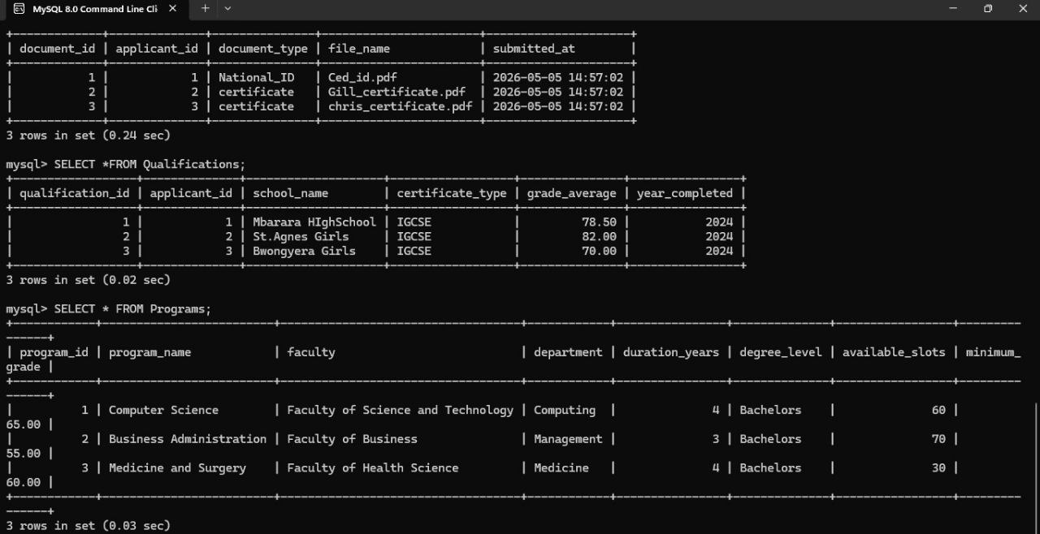

3.4 MySQL Workbench Query Verification
Figure 5 confirms successful execution of SQL SELECT queries in MySQL Workbench, showing 2 rows returned from the admissions table and 3 rows from the applications table. This validates data integrity and confirms the database is fully operational and accessible from both the CLI and GUI tools.

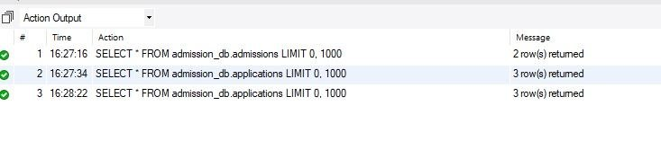

3.5 Database Schema Modifications
The following SQL alterations were applied on top of the original schema to support the full application workflow:

-- Add password authentication to applicants
ALTER TABLE Applicants
ADD password_hash VARCHAR(255) NOT NULL AFTER email;

-- Create Admins table for admin login
CREATE TABLE Admins (
admin_id INT AUTO_INCREMENT PRIMARY KEY,
username VARCHAR(50) NOT NULL UNIQUE,
password_hash VARCHAR(255) NOT NULL,
full_name VARCHAR(100)
) ENGINE=InnoDB;

-- Extend Applications for approval/rejection workflow
ALTER TABLE Applications
MODIFY status ENUM('Pending','Approved','Rejected') NOT NULL DEFAULT 'Pending',
ADD admin_remarks TEXT NULL;

-- Link Documents to specific Applications
ALTER TABLE Documents
ADD application_id INT AFTER applicant_id,
ADD FOREIGN KEY (application_id)
REFERENCES Applications(application_id) ON DELETE CASCADE;

